

For the safety of all participants we do not allow dogs at library events

All events begun at 6:15 PM at the Village Park unless otherwise stated

2024 Summer Reading Events

June 11 Kick-OfF Foam Party!!

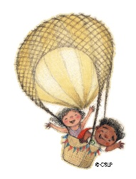On the community center lawn--Bring a towel. There will be a food truck with hotdogs and brats if you would like to purchase dinner. Snow cones will be available free of charge

June 18 Adventures in nature

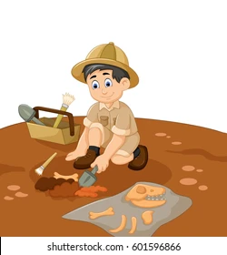 grow mushrooms, make dried flower bookmarks, and build an ecosystem

June 25 Adventures in Archeology

Participate in an actual dinosaur dig!! Make an agate necklace

July 2 adventures in the Night Sky

 Make galaxy rocks, constellation jars and more!

July 9 adventures in clay

Make clay creations

July 16 Adventures in Magic with Cameron Zvara

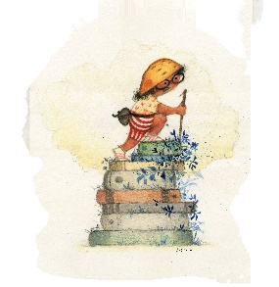 Magic and Comedy with Cameron!! At the Vermontville community center

July 23 memories of your adventures

Make a memory board, and help us fill a time capsule

July 30 wrap up summer reading!!

Don’t forget to join our reading challenge on the next page!

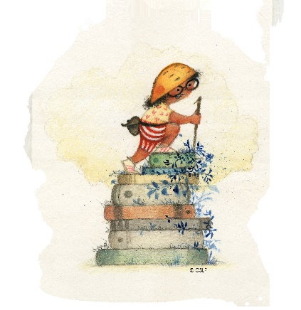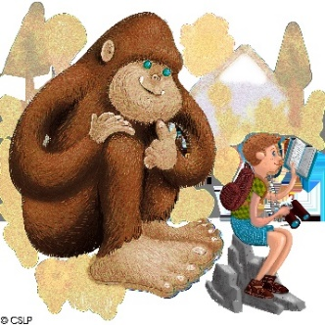

Reading Challenge 2024

Adventure begins at Your library

2024 Summer Reading Challenge

We challenge you to spend lots of time reading this summer!!

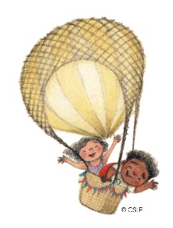Keep track of your reading time and earn prizes!

Here are the rules:

1. Books should come from the Vermontville Township Library. You can also use books borrowed from MeLCat, Hoopla and libby.

2. Books must be at your reading level.

3. Each dot on the reading log represents 30 minutes spent reading. Mark off every 30 minutes with the provided stickers.

4. When you have filled 10 dots, you will earn a Brag Tag. There are 50 dots per sheet, so you can earn 5 Brag Tags with one sheet. You can earn 10 different Brag Tags during the Summer Reading Challenge.

5. In addition we have Brag Tag Book Cover tags. Read the book, earn the Brag Tag. Each book cover brag tag earns 1 ticket for the prize drawing.

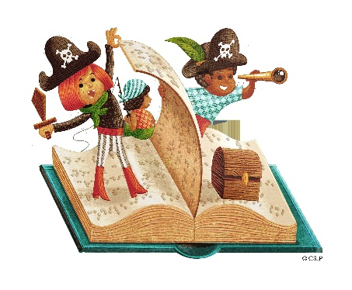6. Every full sheet completed will earn 1 entry into the Grand Prize Drawing.